**Correlation**

Welcome to the final chapter of the course, where we'll talk about correlation and experimental design.

**Relationships between two variables**

Before we dive in, let's talk about relationships between numeric variables. We can visualize these kinds of relationships with scatter plots - in this scatterplot, we can see the relationship between the total amount of sleep mammals get and the amount of REM sleep they get. The variable on the x-axis is called the explanatory or independent variable, and the variable on the y-axis is called the response or dependent variable.

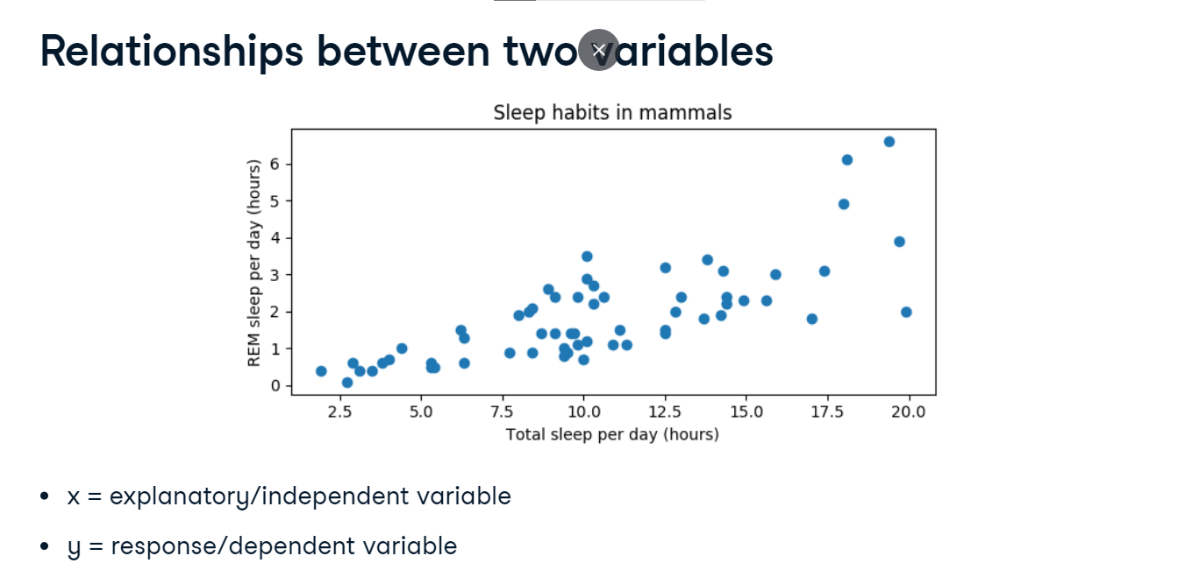

**Correlation coefficient**

We can also examine relationships between two numeric variables using a number called the correlation coefficient. This is a number between -1 and 1, where the magnitude corresponds to the strength of the relationship between the variables, and the sign, positive or negative, corresponds to the direction of the relationship.

**Magnitude = strength of relationship**

Here's a scatterplot of 2 variables, x and y, that have a correlation coefficient of 0-point-99. Since the data points are closely clustered around a line, we can describe this as a near-perfect or very strong relationship. If we know what x is, we'll have a pretty good idea of what the value of y could be.

Here, x and y have a correlation coefficient of 0-point-75, and the data points are a bit more spread out.

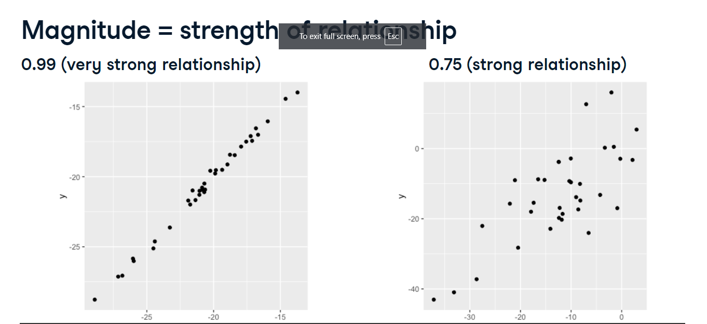

**Magnitude = strength of relationship**

In this plot, x and y have a correlation of 0-point-56 and are therefore moderately correlated.

A correlation coefficient around 0-point-2 would be considered a weak relationship.

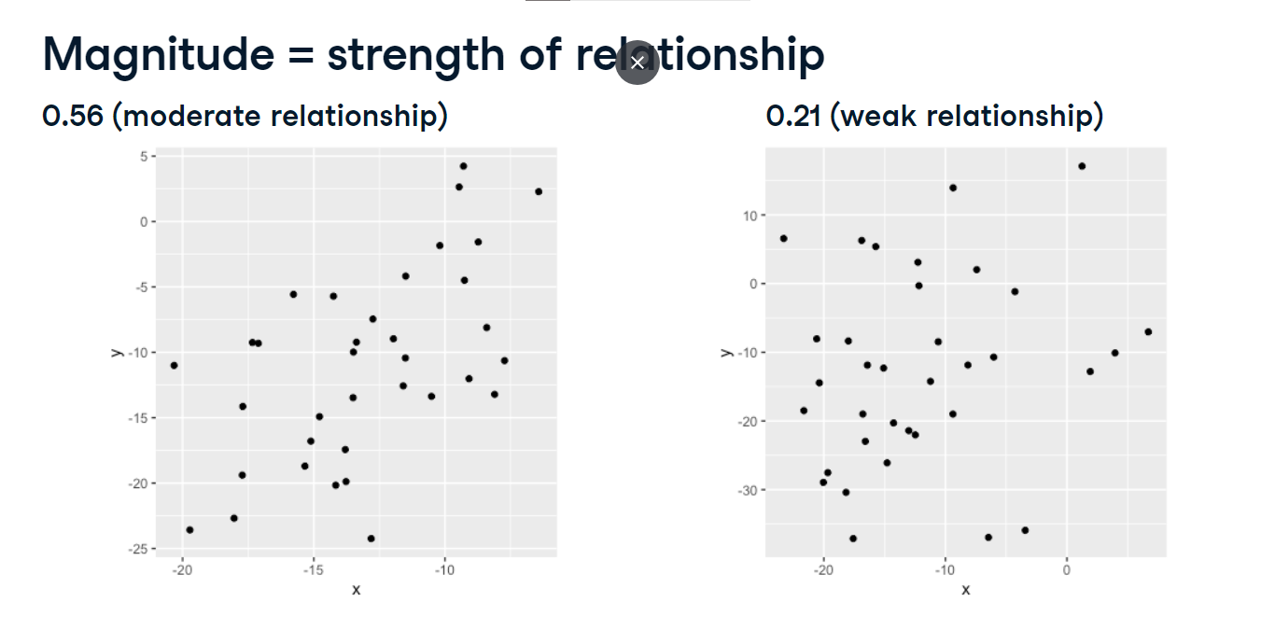 **Magnitude = strength of relationship**

When the correlation coefficient is close to 0, x and y have no relationship and the scatterplot looks completely random. This means that knowing the value of x doesn't tell us anything about the value of y.

**Sign = direction**

The sign of the correlation coefficient corresponds to the direction of the relationship. A positive correlation coefficient indicates that as x increases, y also increases. A negative correlation coefficient indicates that as x increases, y decreases.

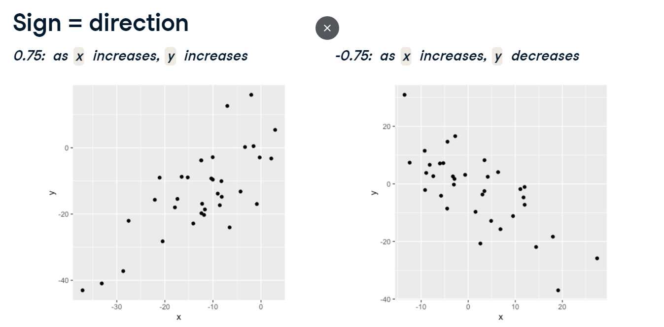

**Visualizing relationships**

To visualize relationships between two variables, we can use a scatterplot. We'll use seaborn, which is a plotting package built on top of matplotlib. We import seaborn as sns, which is the alias commonly used for seaborn. We create a scatterplot using sns-dot-scatterplot, passing it the name of the variable for the x-axis, the name of the variable for the y-axis, as well as the msleep DataFrame to the data argument. Finally, we call plt-dot-show. 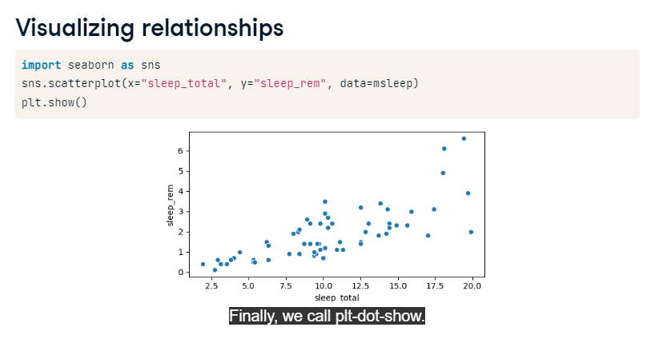

**Adding a trendline**

We can add a linear trendline to the scatterplot using seaborn's lmplot() function. It takes the same arguments as sns-dot-scatterplot, but we'll set ci to None so that there aren't any confidence interval margins around the line. Trendlines like this can be helpful to more easily see a relationship between two variables.

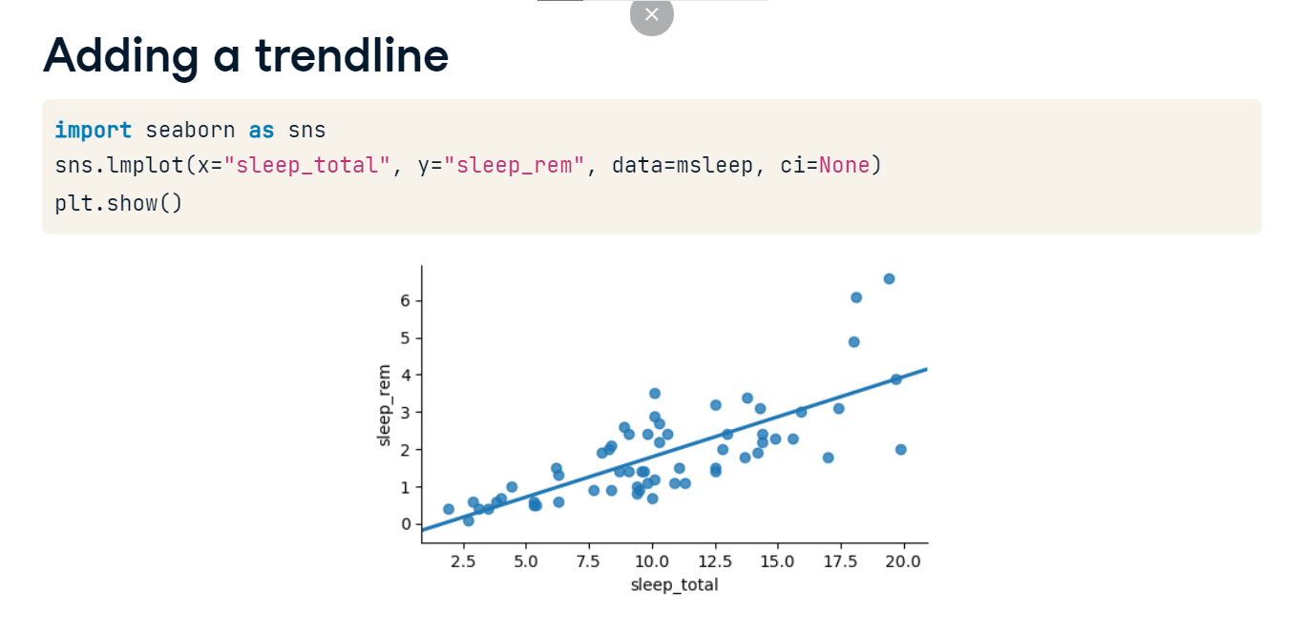

**Computing correlation**

To calculate the correlation coefficient between two Series, we can use the dot-corr method. If we want the correlation between the sleep_total and sleep_rem columns of msleep, we can take the sleep_total column and call dot-corr on it, passing in the other Series we're interested in. Note that it doesn't matter which Series the method is invoked on and which is passed in since the correlation between x and y is the same thing as the correlation between y and x.

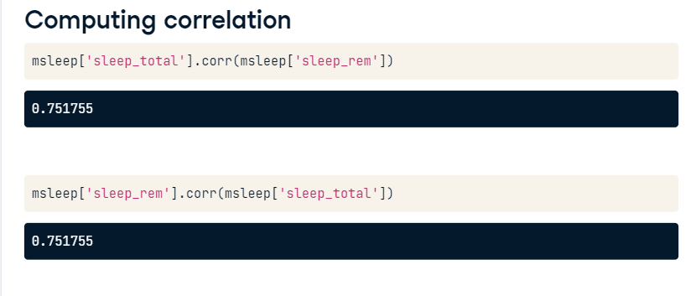

**Many ways to calculate correlation**

There's more than one way to calculate correlation, but the method we've been using in this video is called the Pearson product-moment correlation, which is also written as r. This is the most commonly used measure of correlation. Mathematically, it's calculated using this formula where x and y bar are the means of x and y, and sigma x and sigma y are the standard deviations of x and y. The formula itself isn't important to memorize, but know that there are variations of this formula that measure correlation a bit differently, such as Kendall's tau and Spearman's rho, but those are beyond the scope of this course.

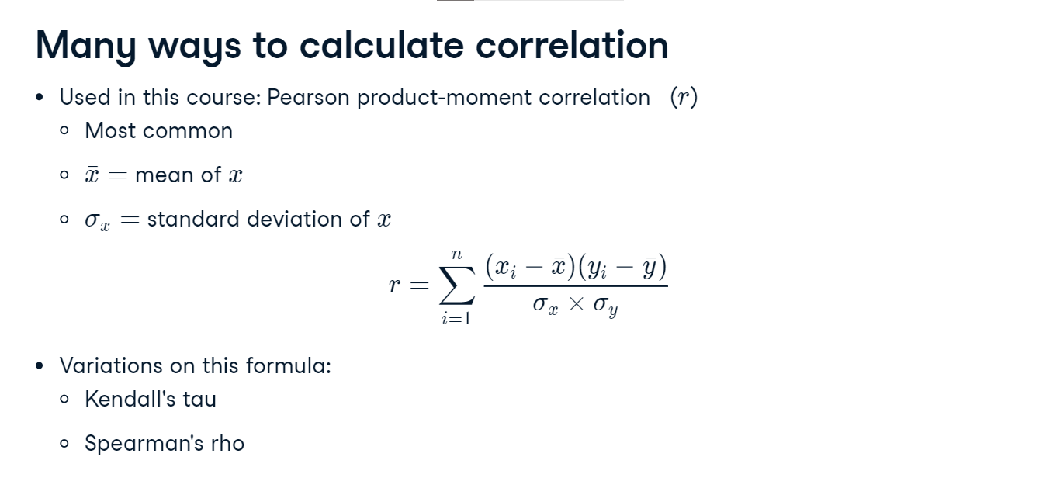

**Correlation caveats**

00:00 - 00:06

While correlation is a useful way to quantify relationships, there are some caveats.

**2. Non-linear relationships**

00:06 - 00:16

Consider this data. There is clearly a relationship between x and y, but when we calculate the correlation, we get 0-point-18.

**3. Non-linear relationships**

00:16 - 00:30

This is because the relationship between the two variables is a quadratic relationship, not a linear relationship. The correlation coefficient measures the strength of linear relationships, and linear relationships only.

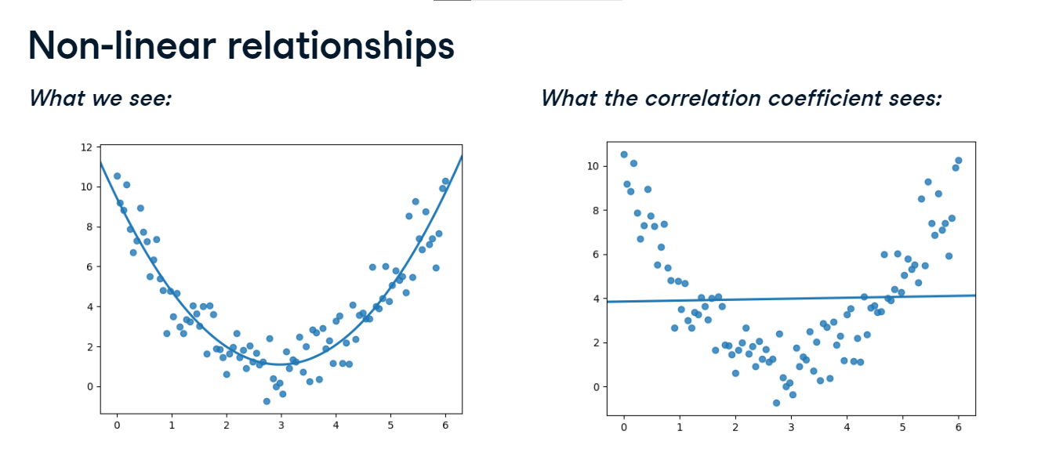

**4. Correlation only accounts for linear relationships**

00:30 - 00:38

Just like any summary statistic, correlation shouldn't be used blindly, and you should always visualize your data when possible.

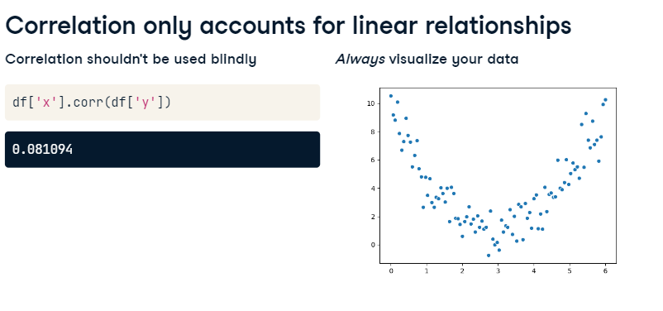

**5. Mammal sleep data**

00:38 - 00:41

Let's return to the mammal sleep data.

**6. Body weight vs. awake time**

00:41 - 01:00

Here's a scatterplot of each mammal's body weight versus the time they spend awake each day. The relationship between these variables is definitely not a linear one. The correlation between body weight and awake time is only about 0-point-3, which is a weak linear relationship.

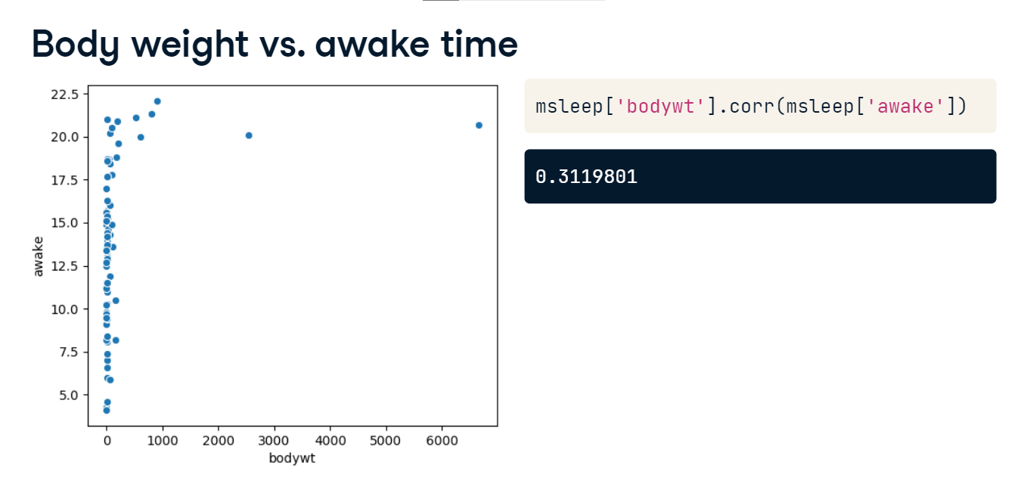

**7. Distribution of body weight**

01:00 - 01:12

If we take a closer look at the distribution for bodywt, it's highly skewed. There are lots of lower weights and a few weights that are much higher than the rest.

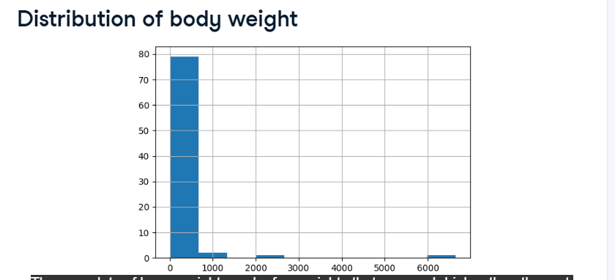

**8. Log transformation**

01:12 - 01:44

When data is highly skewed like this, we can apply a log transformation. We'll create a new column called log_bodywt which holds the log of each body weight. We can do this using np-dot-log. If we plot the log of bodyweight versus awake time, the relationship looks much more linear than the one between regular bodyweight and awake time. The correlation between the log of bodyweight and awake time is about 0-point-57, which is much higher than the 0-point-3 we had before.

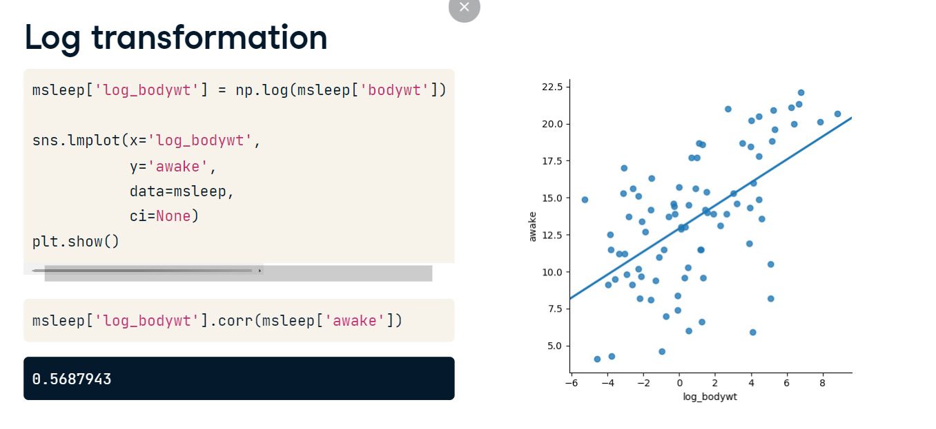

**9. Other transformations**

01:44 - 02:13

In addition to the log transformation, there are lots of other transformations that can be used to make a relationship more linear, like taking the square root or reciprocal of a variable. The choice of transformation will depend on the data and how skewed it is. These can be applied in different combinations to x and y, for example, you could apply a log transformation to both x and y, or a square root transformation to x and a reciprocal transformation to y.

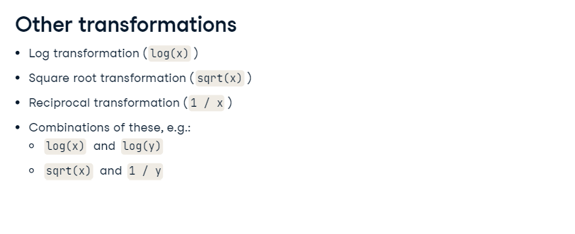

**10. Why use a transformation?**

02:13 - 02:34

So why use a transformation? Certain statistical methods rely on variables having a linear relationship, like calculating a correlation coefficient. Linear regression is another statistical technique that requires variables to be related in a linear manner, which you can learn all about in this course.

**11. Correlation does not imply causation**

02:34 - 03:14

Let's talk about one more important caveat of correlation that you may have heard about before: correlation does not imply causation. This means that if x and y are correlated, x doesn't necessarily cause y. For example, here's a scatterplot of the per capita margarine consumption in the US each year and the divorce rate in the state of Maine. The correlation between these two variables is 0-point-99, which is nearly perfect. However, this doesn't mean that consuming more margarine will cause more divorces. This kind of correlation is often called a spurious correlation.

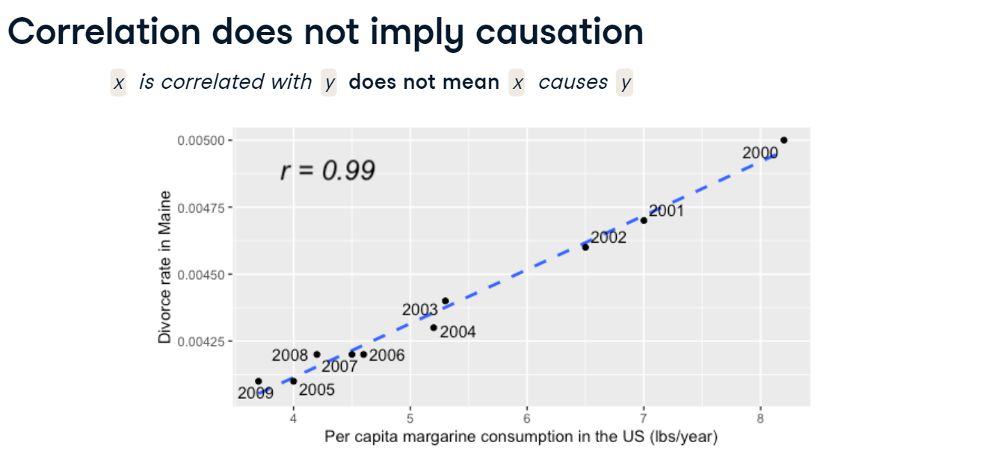

**12. Confounding**

03:14 - 03:34

A phenomenon called confounding can lead to spurious correlations. Let's say we want to know if drinking coffee causes lung cancer. Looking at the data, we find that coffee drinking and lung cancer are correlated, which may lead us to think that drinking more coffee will give you lung cancer.

**13. Confounding**

03:34 - 03:39

However, there is a third, hidden variable at play, which is smoking.

**14. Confounding**

03:39 - 03:43

Smoking is known to be associated with coffee consumption.

**15. Confounding**

03:43 - 03:48

It is also known that smoking causes lung cancer.

**16. Confounding**

03:48 - 04:35

In reality, it turns out that coffee does not cause lung cancer and is only associated with it, but it appeared causal due to the third variable, smoking. This third variable is called a confounder, or lurking variable. This means that the relationship of interest between coffee and lung cancer is a spurious correlation. Another example of this is the relationship between holidays and retail sales. While it might be that people buy more around holidays as a way of celebrating, it's hard to tell how much of the increased sales is due to holidays, and how much is due to the special deals and promotions that often run around holidays. Here, special deals confound the relationship between holidays and sales.

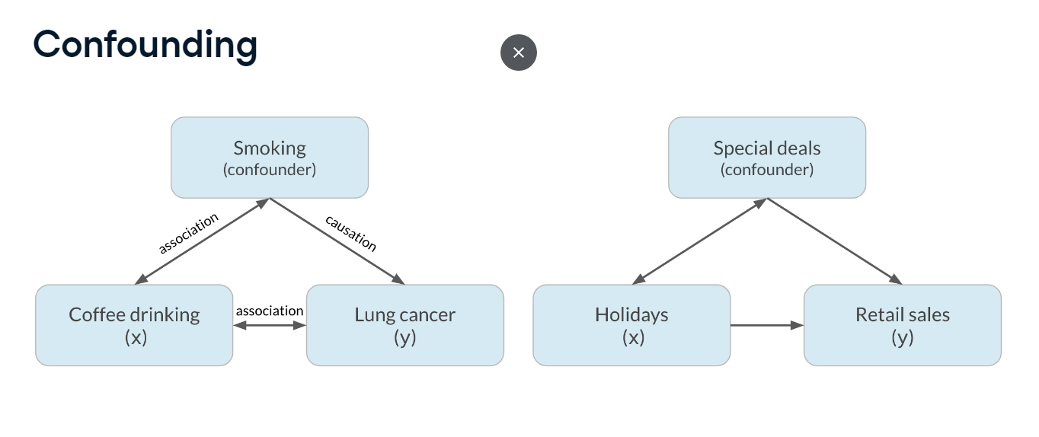

**Design of experiments**

Often, data is created as a result of a study that aims to answer a specific question. However, data needs to be analyzed and interpreted differently depending on how the data was generated and how the study was designed.

**Vocabulary**

Experiments generally aim to answer a question in the form, "What is the effect of the treatment on the response?" In this setting, treatment refers to the explanatory or independent variable, and response refers to the response or dependent variable. For example, what is the effect of an advertisement on the number of products purchased? In this case, the treatment is an advertisement, and the response is the number of products purchased.

**Controlled experiments**

In a controlled experiment, participants are randomly assigned to either the treatment group or the control group, where the treatment group receives the treatment and the control group does not. A great example of this is an A/B test. In our example, the treatment group will see an advertisement, and the control group will not. Other than this difference, the groups should be comparable so that we can determine if seeing an advertisement causes people to buy more. If the groups aren't comparable, this could lead to confounding, or bias. If the average age of participants in the treatment group is 25 and the average age of participants in the control group is 50, age could be a potential confounder if younger people are more likely to purchase more, and this will make the experiment biased towards the treatment.

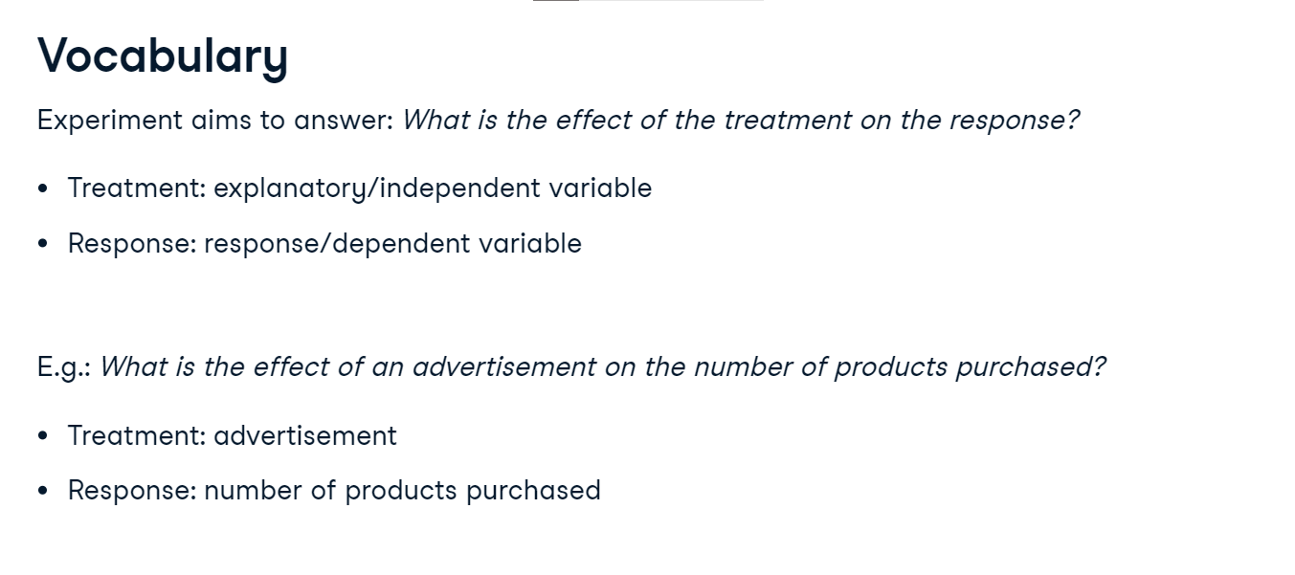

**The gold standard of experiments will use...**

The gold standard, or ideal experiment, will eliminate as much bias as possible by using certain tools. The first tool to help eliminate bias in controlled experiments is to use a randomized controlled trial. In a randomized controlled trial, participants are randomly assigned to the treatment or control group and their assignment isn't based on anything other than chance. Random assignment like this helps ensure that the groups are comparable. The second way is to use a placebo, which is something that resembles the treatment, but has no effect. This way, participants don't know if they're in the treatment or control group. This ensures that the effect of the treatment is due to the treatment itself, not the idea of getting the treatment. This is common in clinical trials that test the effectiveness of a drug. The control group will still be given a pill, but it's a sugar pill that has minimal effects on the response.

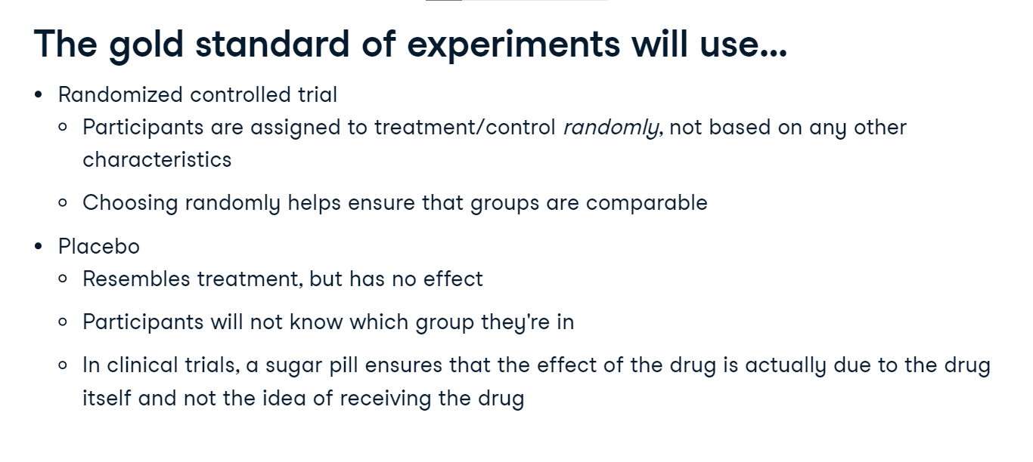

**The gold standard of experiments will use...**

In a double-blind experiment, the person administering the treatment or running the experiment also doesn't know whether they're administering the actual treatment or the placebo. This protects against bias in the response as well as the analysis of the results. These different tools all boil down to the same principle: if there are fewer opportunities for bias to creep into your experiment, the more reliably you can conclude whether the treatment affects the response.

**Observational studies**

The other kind of study we'll discuss is the observational study. In an observational study, participants are not randomly assigned to groups. Instead, participants assign themselves, usually based on pre-existing characteristics. This is useful for answering questions that aren't conducive to a controlled experiment. If you want to study the effect of smoking on cancer, you can't force people to start smoking. Similarly, if you want to study how past purchasing behavior affects whether someone will buy a product, you can't force people to have certain past purchasing behavior. Because assignment isn't random, there's no way to guarantee that the groups will be comparable in every aspect, so observational studies can't establish causation, only association. The effects of the treatment may be confounded by factors that got certain people into the control group and certain people into the treatment group. However, there are ways to control for confounders, which can help strengthen the reliability of conclusions about association.

**Longitudinal vs. cross-sectional studies**

The final important distinction to make is between longitudinal and cross-sectional studies. In a longitudinal study, the same participants are followed over a period of time to examine the effect of treatment on the response. In a cross-sectional study, data is collected from a single snapshot in time. If you wanted to investigate the effect of age on height, a cross-sectional study would measure the heights of people of different ages and compare them. However, the results will be confounded by birth year and lifestyle since it's possible that each generation is getting taller. In a longitudinal study,the same people would have their heights recorded at different points in their lives, so the confounding is eliminated. It's important to note that longitudinal studies are more expensive, and take longer to perform, while cross-sectional studies are cheaper, faster, and more convenient.

